EWMA correlation: AUDUSD and NZDUSD
Method 06 / daily log returns / lambda = 0.94 / Alpari D1 full available history

Study setup
Logical pair: AUDUSD , NZDUSD
Broker symbols: AUDUSD_i , NZDUSD_i
Snapshot: 2026-11-03_majors_alpari_D1
Timeframe: D1
Matched return window: 1999-01-05 to 2026-11-02 (UTC bar dates)
Matched return count n: 7202
Dropped unfinished last bar dated 2026-11-03 UTC after a tick-volume check against the prior complete day.
Lambda: 0.94 (today weight 0.06)
Burn-in ignored in path summaries and chart: first 60 updates
Mean adjustment: each leg demeaned by its mean on the matched rows
Seeds: c_0 = v_x,0 = v_y,0 = 0
Complete matched rows (Excel): AUDUSD-NZDUSD_EWMA_D1.xlsx
Complete matched rows (HTML table): AUDUSD-NZDUSD_EWMA_D1_data.html

Method carried forward
EWMA correlation updates covariance and variances of mean-adjusted daily log returns of close, ln(close_t / close_t-1), with lambda = 0.94 (6% weight on today's product or square, 94% on yesterday's EWMA state). Quotes are not inverted. Each leg is demeaned by its mean on the matched rows; that mean uses the full sample, so the rho path is a full-sample description, not a live filter. Seeds start at zero. Path summaries and the chart ignore the first 60 updates so the zero seed has faded. The headline is rho on the last day. rho is symmetric under swap of the two symbols. A high |rho| does not prove cause, lead-lag, or a trading signal. Today's return sits inside today's rho, so the estimate can only inform a later decision. Same-sample Pearson r is a side check only.

Results
Latest EWMA rho: 0.367270
Post-burn-in path (n=7142): mean=0.808000, median=0.828552, min=0.190548, max=0.968503, std=0.107003
Share of post-burn-in days with |rho| >= 0.4: 99.62%; |rho| >= 0.7: 85.70%
Same-sample Pearson r: 0.828722
Latest rho minus r: -0.461452

Conclusion
Over 7202 matched daily log-return rows for AUDUSD and NZDUSD (broker quote directions unchanged), latest EWMA rho with lambda=0.94 is 0.3673 (positive, weak recent linear link in this sample). After a 60-day burn-in, path mean is 0.8080, std is 0.1070, and the range is [0.1905, 0.9685]. Same-sample Pearson r is 0.8287 (latest rho minus r = -0.4615). This does not establish cause, lead-lag, or a lasting trading rule.

Charts
Daily closes

Daily log returns
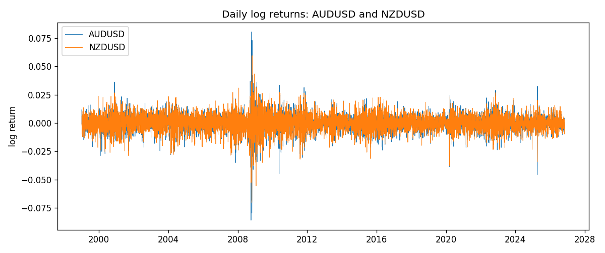
EWMA rho path with Pearson r reference
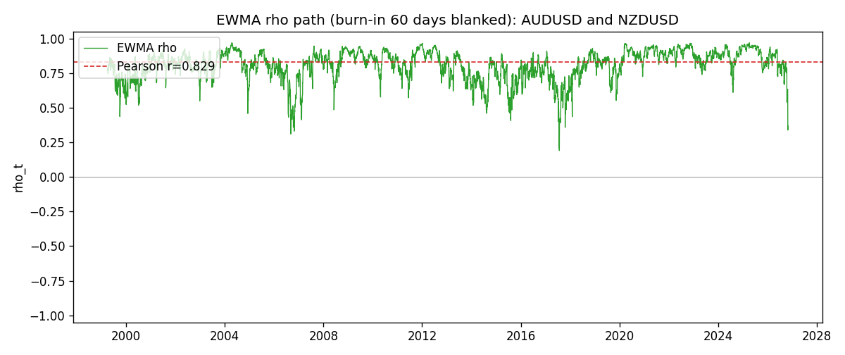

Data report
Every matched row that entered the EWMA recursion is stored in the sibling Excel workbook named AUDUSD-NZDUSD_EWMA_D1.xlsx. That file is the complete data archive for redrawing charts. Embedding all rows as a Word table is impractical at this length; the Word file holds the column list, column summaries, and the first and last 15 matched rows.
Columns: time, AUDUSD_open, NZDUSD_open, AUDUSD_high, NZDUSD_high, AUDUSD_low, NZDUSD_low, AUDUSD_close, NZDUSD_close, AUDUSD_tick_volume, NZDUSD_tick_volume, AUDUSD_spread, NZDUSD_spread, AUDUSD_real_volume, NZDUSD_real_volume, AUDUSD_log_return, NZDUSD_log_return, AUDUSD_x_demeaned, NZDUSD_y_demeaned, c_t, v_x, v_y, rho_t
Column summaries (matched calculation rows)
column | count | mean | std | min | 25% | 50% | 75% | max
AUDUSD_open | 7202 | 0.75190973 | 0.13530408 | 0.4785 | 0.6610275 | 0.731395 | 0.8089525 | 1.10284
NZDUSD_open | 7202 | 0.65620671 | 0.10825448 | 0.3913 | 0.5910925 | 0.6683 | 0.724695 | 0.88218
AUDUSD_high | 7202 | 0.75595988 | 0.13586572 | 0.4878 | 0.6647 | 0.734725 | 0.81501 | 1.10795
NZDUSD_high | 7202 | 0.66012182 | 0.1087492 | 0.3961 | 0.5946275 | 0.67189 | 0.7292675 | 0.88421
AUDUSD_low | 7202 | 0.74785283 | 0.13461673 | 0.4775 | 0.6577 | 0.727385 | 0.8042 | 1.0975
NZDUSD_low | 7202 | 0.6525168 | 0.10784895 | 0.3897 | 0.587955 | 0.66406 | 0.72082 | 0.87988
AUDUSD_close | 7202 | 0.75195766 | 0.13528533 | 0.4786 | 0.6611925 | 0.731645 | 0.809065 | 1.10169
NZDUSD_close | 7202 | 0.65627751 | 0.10825012 | 0.3907 | 0.59141 | 0.668305 | 0.7249175 | 0.8822
AUDUSD_tick_volume | 7202 | 77337.3 | 138128.78 | 109 | 5435.5 | 43320 | 71312.25 | 1234623
NZDUSD_tick_volume | 7202 | 68561.899 | 123036.41 | 17 | 5505.5 | 33822 | 58470.25 | 1127682
AUDUSD_spread | 7202 | 30.821161 | 16.887481 | 0 | 13 | 30 | 50 | 50
NZDUSD_spread | 7202 | 30.366287 | 25.672101 | 0 | 9 | 17 | 50 | 80
AUDUSD_real_volume | 7202 | 5.2413627e+09 | 1.253718e+11 | 0 | 0 | 0 | 0 | 3.811512e+12
NZDUSD_real_volume | 7202 | 1.6659405e+10 | 8.488719e+10 | 0 | 0 | 0 | 0 | 2.705649e+12
AUDUSD_log_return | 7202 | 2.237e-05 | 0.00754318 | -0.08602525 | -0.00386318 | 0.00028132 | 0.00415217 | 0.0806166
NZDUSD_log_return | 7202 | 5.13e-06 | 0.00764596 | -0.07027433 | -0.00426304 | 0.00021271 | 0.00457975 | 0.05966839
AUDUSD_x_demeaned | 7202 | -0 | 0.00754318 | -0.08604762 | -0.00388555 | 0.00025896 | 0.0041298 | 0.08059423
NZDUSD_y_demeaned | 7202 | -0 | 0.00764596 | -0.07027946 | -0.00426817 | 0.00020758 | 0.00457462 | 0.05966326
c_t | 7202 | 4.778e-05 | 6.814e-05 | 9e-08 | 2.226e-05 | 3.21e-05 | 5.062e-05 | 0.00113824
v_x | 7202 | 5.686e-05 | 0.00010018 | 4e-08 | 2.62e-05 | 3.686e-05 | 5.877e-05 | 0.0017331
v_y | 7202 | 5.842e-05 | 5.896e-05 | 2.1e-07 | 3.049e-05 | 4.242e-05 | 6.68e-05 | 0.00086265
rho_t | 7202 | 0.80750507 | 0.1070863 | 0.19054755 | 0.75414945 | 0.82781762 | 0.88638101 | 1
First 15 matched rows (selected columns)
time | AUDUSD_close | NZDUSD_close | AUDUSD_log_return | NZDUSD_log_return | AUDUSD_x_demeaned | NZDUSD_y_demeaned | c_t | v_x | v_y | rho_t
1999-01-05 | 0.6215 | 0.5372 | -0.00080418179 | -0.0018597736 | -0.00082654892 | -0.001864904 | 9.2486065e-08 | 4.0990987e-08 | 2.0867202e-07 | 1
1999-01-06 | 0.6289 | 0.5383 | 0.011836351 | 0.0020455609 | 0.011813983 | 0.0020404305 | 1.5332737e-06 | 8.4127438e-06 | 4.4595311e-07 | 0.79160084
1999-01-07 | 0.6345 | 0.5417 | 0.0088650256 | 0.0062963171 | 0.0088426585 | 0.0062911867 | 4.7791262e-06 | 1.2599536e-05 | 2.7939377e-06 | 0.80549503
1999-01-08 | 0.6347 | 0.5414 | 0.00031515916 | -0.00055396548 | 0.00029279202 | -0.00055909586 | 4.4825567e-06 | 1.1848707e-05 | 2.6450568e-06 | 0.80070549
1999-01-11 | 0.6393 | 0.547 | 0.0072213815 | 0.010290425 | 0.0071990143 | 0.010285295 | 8.6562424e-06 | 1.4247333e-05 | 8.8335908e-06 | 0.77160313
1999-01-12 | 0.6362 | 0.5441 | -0.0048608485 | -0.0053157489 | -0.0048832156 | -0.0053208793 | 9.6958479e-06 | 1.4823241e-05 | 1.0002281e-05 | 0.79627795
1999-01-13 | 0.6312 | 0.5387 | -0.0078902098 | -0.0099742238 | -0.0079125769 | -0.0099793542 | 1.3851841e-05 | 1.7690379e-05 | 1.5377394e-05 | 0.83984196
1999-01-14 | 0.6295 | 0.5386 | -0.002696916 | -0.00018564931 | -0.0027192832 | -0.00019077968 | 1.3051858e-05 | 1.7072626e-05 | 1.4456935e-05 | 0.83077624
1999-01-15 | 0.634 | 0.5382 | 0.007123101 | -0.00074294208 | 0.0071007338 | -0.00074807246 | 1.1950035e-05 | 1.9073494e-05 | 1.3623095e-05 | 0.7413378
1999-01-18 | 0.6346 | 0.5372 | 0.00094592471 | -0.0018597736 | 0.00092355758 | -0.001864904 | 1.1129692e-05 | 1.7980262e-05 | 1.3014382e-05 | 0.72756763
1999-01-19 | 0.6392 | 0.5382 | 0.0072225153 | 0.0018597736 | 0.0072001482 | 0.0018546433 | 1.1263133e-05 | 2.0011974e-05 | 1.2439901e-05 | 0.71384805
1999-01-20 | 0.64 | 0.5404 | 0.0012507819 | 0.0040793678 | 0.0012284148 | 0.0040742374 | 1.0887636e-05 | 1.8901796e-05 | 1.2689471e-05 | 0.70300804
1999-01-21 | 0.6405 | 0.5426 | 0.00078094498 | 0.0040627941 | 0.00075857785 | 0.0040576638 | 1.0419061e-05 | 1.7802214e-05 | 1.2915981e-05 | 0.68711253
1999-01-22 | 0.6327 | 0.5361 | -0.012252745 | -0.012051689 | -0.012275112 | -0.01205682 | 1.8673846e-05 | 2.5774785e-05 | 2.0863037e-05 | 0.80528109
1999-01-25 | 0.6302 | 0.5342 | -0.0039591468 | -0.0035504102 | -0.003981514 | -0.0035555405 | 1.8402802e-05 | 2.5179445e-05 | 2.0369766e-05 | 0.81258322
Last 15 matched rows (selected columns)
time | AUDUSD_close | NZDUSD_close | AUDUSD_log_return | NZDUSD_log_return | AUDUSD_x_demeaned | NZDUSD_y_demeaned | c_t | v_x | v_y | rho_t
2026-10-13 | 0.69821 | 0.56127 | 0.0035007712 | 0.0047326165 | 0.003478404 | 0.0047274861 | 1.2211134e-05 | 1.4132788e-05 | 1.695735e-05 | 0.78879305
2026-10-14 | 0.69715 | 0.55918 | -0.0015193215 | -0.0037306483 | -0.0015416886 | -0.0037357786 | 1.182403e-05 | 1.3427429e-05 | 1.6777271e-05 | 0.78778631
2026-10-15 | 0.69191 | 0.56185 | -0.0075447063 | 0.0047634855 | -0.0075670734 | 0.0047583551 | 8.954179e-06 | 1.605742e-05 | 1.7129152e-05 | 0.53990826
2026-10-16 | 0.69426 | 0.56509 | 0.0033906408 | 0.0057501001 | 0.0033682736 | 0.0057449698 | 9.5779661e-06 | 1.577469e-05 | 1.8081683e-05 | 0.56711802
2026-10-19 | 0.6978 | 0.56616 | 0.0050859986 | 0.0018917133 | 0.0050636315 | 0.0018865829 | 9.5764658e-06 | 1.6366631e-05 | 1.7210334e-05 | 0.57059895
2026-10-20 | 0.70022 | 0.56827 | 0.0034620426 | 0.0037199341 | 0.0034396755 | 0.0037148037 | 9.768541e-06 | 1.6094515e-05 | 1.70057e-05 | 0.59046411
2026-10-21 | 0.70275 | 0.57003 | 0.0036066384 | 0.0030923331 | 0.0035842713 | 0.0030872028 | 9.8463509e-06 | 1.5899664e-05 | 1.6557207e-05 | 0.60685899
2026-10-22 | 0.70186 | 0.56815 | -0.0012672558 | -0.0033035227 | -0.001289623 | -0.003308653 | 9.5115847e-06 | 1.5045472e-05 | 1.6220606e-05 | 0.60885859
2026-10-23 | 0.70353 | 0.56991 | 0.0023765656 | 0.0030929853 | 0.0023541985 | 0.0030878549 | 9.377055e-06 | 1.4475279e-05 | 1.581946e-05 | 0.61966529
2026-10-26 | 0.70128 | 0.56826 | -0.0032032829 | -0.0028993932 | -0.00322565 | -0.0029045235 | 9.3765703e-06 | 1.4231051e-05 | 1.5376468e-05 | 0.63386567
2026-10-27 | 0.70245 | 0.56811 | 0.0016669876 | -0.00026399852 | 0.0016446205 | -0.0002691289 | 8.7874192e-06 | 1.3539475e-05 | 1.4458226e-05 | 0.62806261
2026-10-28 | 0.70533 | 0.56261 | 0.0040915541 | -0.0097283914 | 0.004069187 | -0.0097335218 | 5.8837228e-06 | 1.3720603e-05 | 1.9275219e-05 | 0.36179782
2026-10-29 | 0.70245 | 0.56296 | -0.0040915541 | 0.00062190714 | -0.0041139212 | 0.00061677677 | 5.3784572e-06 | 1.3912828e-05 | 1.8141531e-05 | 0.33854238
2026-10-30 | 0.70316 | 0.56307 | 0.0010102376 | 0.00019537668 | 0.0009878705 | 0.0001902463 | 5.0670261e-06 | 1.3136611e-05 | 1.7055211e-05 | 0.3385189
2026-11-02 | 0.69971 | 0.56161 | -0.0049184984 | -0.0025962955 | -0.0049408656 | -0.0026014259 | 5.5342023e-06 | 1.3813144e-05 | 1.6437943e-05 | 0.36726964

